**Research without Borders – Ethiopia J. Health Sciences**

**16-26 October Jimma / Addis Ababa, Ethiopia**

**Laura Casares, Louise Curtis**

**Ethiopian Journal of Health Sciences - background**

One of 5 academic journals from Jimma University, EJHS is the longest-established having been in publication since 1990. The Journal is relatively well developed in terms of having a robust editorial/peer review process and is widely indexed. It is experiencing significant growth in submissions putting the current (very committed) team under some pressure in terms of the time they have to dedicate to the Journal. The Editor-in-Chief Abraham Haileamlak (asratab@yahoo.com) and the managing (language) editor Tekle Ferede Metaferia (tekle.ferede2014@gmail.com) are both looking to find successors and move on from the Journal in the short term. We understand a successor Editor-in-Chief has already been identified but they are still missing approval from the University.

The journal also has 2 intern editors who perform the initial checks on submissions – we only met one while in Jimma - Yibeltal Siraneh Belete ([yibeltalsiraneh@gmail.com](mailto:yibeltalsiraneh@gmail.com)) – who takes his role seriously and is dedicated to the Journal. We did not meet the 3 associate editors as apparently they are not at all active and will be rotated off the journal as soon as the Jimma University Institute of Health approved the newly proposed editorial policy submitted by Abraham.

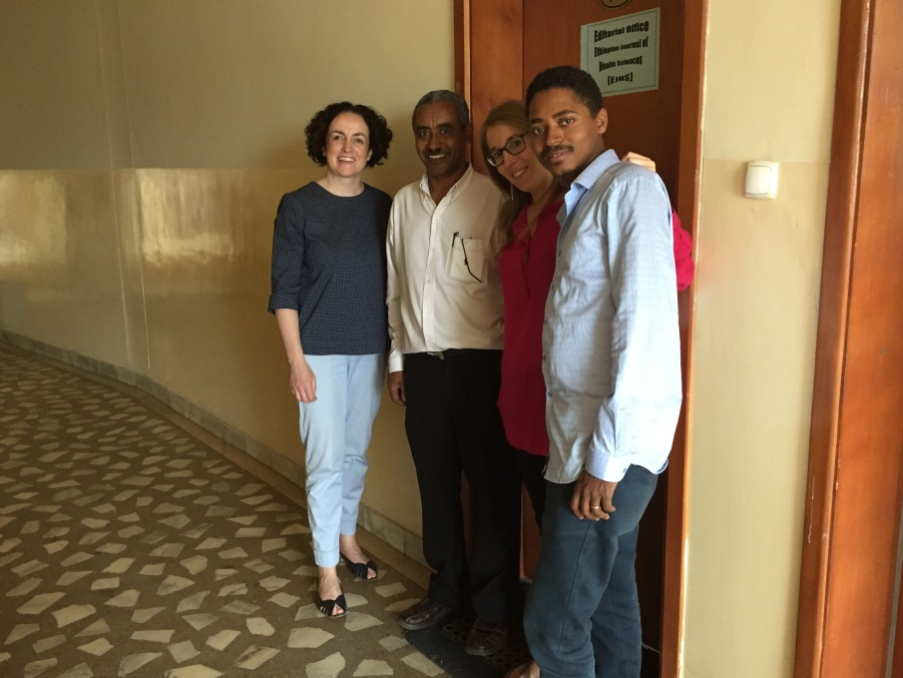

1 With Abraham and Yibeltal outside the EJHS editorial office

**RwB project – aims and achievements**

We submitted a proposed project plan by email prior to our visit (see Appendix A) which served as a useful guideline for discussions while in Jimma. Abraham had limited time available as he is currently on sabbatical to the Ministry of Health in Addis Ababa, however, we did meet twice in Jimma and again at the end of our stay in Addis. All other discussions took place with Tekle and Yibeltal in between their (heavy) teaching schedules though we found that any conclusions needed to be approved by Abraham before implementation.

Progress made during our visit can be summarised as follows:

* Business Plan
  + Suggested some additions to clarify the purpose of the business plan, (interim) goals and expected timelines and add an executive summary/conclusions.
  + Worked with Tekle to better describe the competitive environment of the Journal and how it performs against key competitors (Appendix B) – the mission of the Journal is clear (premier medical title in Africa) but needs to be explained in more detail i.e. what does it mean to be the premier journal, what do the Journal team need to do to achieve this development and how can they define some interim goals to monitor progress.

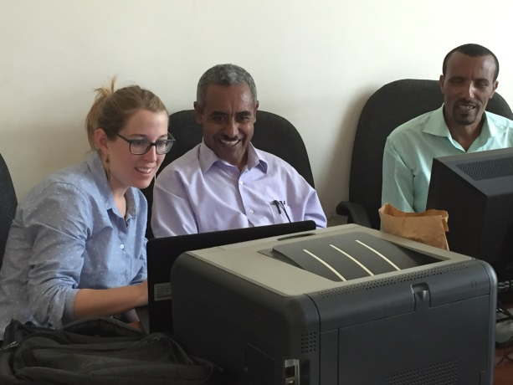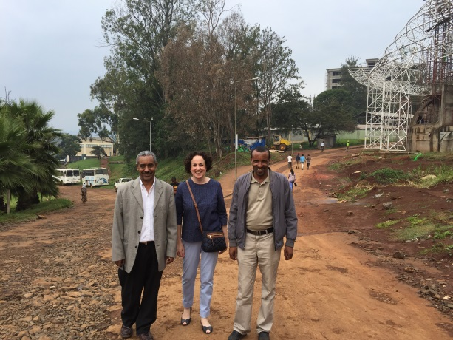

2 Discussions with Abraham and Tekle / returning from coffee break

* Journal website (<https://www.ejhs.ju.edu.et/>)

We agreed with Abraham on some desired changes that should be implemented on the website. We worked directly with the IT contact to improve the journal website including correction of small typos/formatting errors, rearranging the information included under clearer headings and deleting obsolete links. We also suggested including a page providing a clear rationale as to why an author should publish in the Journal (this was developed from scratch in discussion with Tekle, and reviewed with/approved by Abraham but we note needs finalising by the team and is not yet uploaded on the website (see Appendix C).

* Editorial process / Scholar One
  + We reviewed the editorial process in detail with the team and made a number of suggested improvements, e.g. ensure the full technical check is carried out at the beginning of the editorial process, some of which were directly implemented.
  + The team is currently not using ScholarOne for the entire process, only for the editorial management segment. The production (post-acceptance) workflow is carried out by email between Abraham and Tekle which takes a lot of their time– we facilitated contact with the Clarivate support team to address this issue.
* Training
  + On request, we provided two half day workshops during our stay in Jimma:
    - One for the editorial teams of all Jimma University journals covering key topics including editorial process efficiencies, increasing journal visibility (how to get indexed) and finding reviewers (and authors) using Scopus.
    - One for Librarians focusing on the use of Mendeley, both as a reference manager and a social network

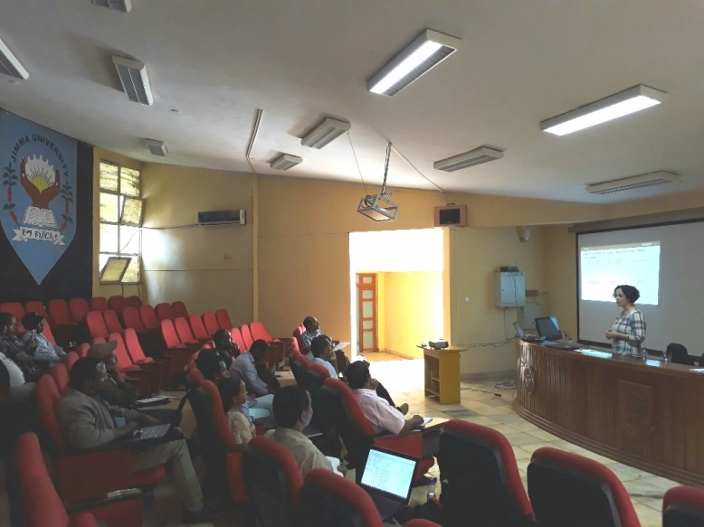 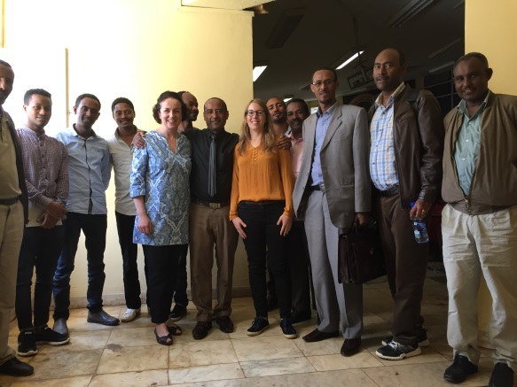

3 Training for library and editorial teams in Jimma

* + We also spent half a day introducing Tekle and Yilbetal to Scopus – Jimma University has access but we found the system is hugely underutilised and wanted to increase understanding of how Scopus can be used to, for example, identify authors to invite to submit to EJHS to support the journal development plan.

**Ethiopian university environment**

Meeting with Abraham but also Teklemichael Wordofa (former Addis Ababa University, now working for the US Embassy and an Elsevier Foundation grant recipient) while in Addis and Tesfaye Refera (Jimma University Director of Publications) we gained some further insights into the Ethiopian publishing and university environment. There are currently some 44 public universities with plans to expand to a total 50. One of the challenges is that universities are not specialised so it remains a challenge to increase performance across a wide range of topics. Prospective students do not have a free choice of their study subject rather this is allocated. Study costs are covered by the government in the form of a loan which the student repays at a later date (once they are earning). There is no country-wide ranking system for Journals but Jimma University applies its own version to promotion applications. Jimma University also has the ultimate ambition to have its own university press also providing publication services for other universities. There appears to be adequate funding available, for example, the University will shortly acquire a site-wide license to a plagiarism checking tool and while we were in Jimma approval was granted for EJHS to hire a full time production editor. There are also signs of (Chinese-sponsored) construction on the university campus (as all around the country) e.g. at the time of our visit a new sports stadium is being constructed.

Through Tecklemichael we tried to set up a meeting with Prof. Masresha Fetene, Executive Director of the Ethiopian Academy of Sciences but it was not possible due to time issues. The Academy is only recently established and would be an interesting point of contact for future volunteers.

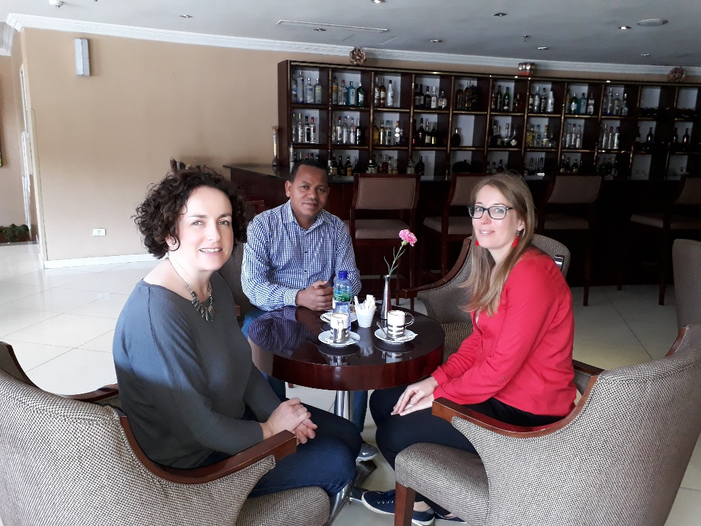

4 Meeting with Tecklemichael in Addis.

**Considerations for future volunteers**

* **EJHS related**
  + It would be best to wait until the new editorial team is in place – or at least the transfer is in motion – before making the next visit. This way any discussions/training will have a longer lasting impact
  + Ensure availability of the Editor-in-Chief to enable decisions/change to be approved and implemented
  + Knowledge about the production process through Scholar One would be useful
* **Non-EJHS related**: we recommend providing training on a wider scale, extending the collaboration to other journals at Jimma University or health related journals in Ethiopia. When visiting Abraham at the Ministry of Health, we briefly met a contact from the Ethiopian Medical Journal who, once he learnt of the purpose of our visit, was also keen to set up a training session.
* **Practical issues**: Jimma is heavily populated city in the rural west part of Ethiopia - a beautiful green region not on the tourist track.
  + Dololo Hotel is one of the newer hotels in Jimma and we believe the best option for a base there – rooms are comfortable (bring your own mosquito net and insecticide!) and water/electricity is pretty reliable, less so wifi connection. There is also a reasonable restaurant on site with Ethiopian and Western food (don’t forgot to try an avocado and guava juice☺). It is some distance (~10 minutes drive) from the University but we were picked up by the university driver each morning/evening and often returned to the hotel for lunch in between – otherwise there are many tuk-tuk for hire.

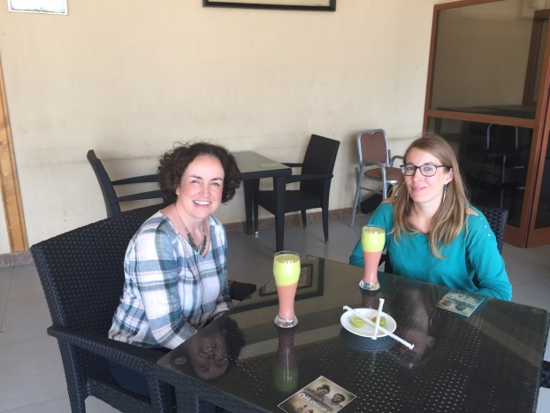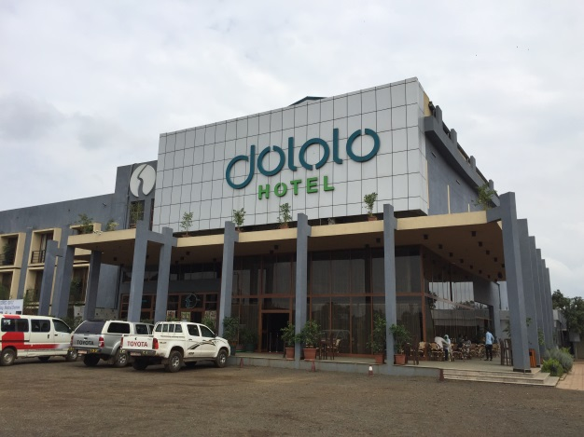

5 Enjoying an avocado & guava juice / Dololo hotel

* + Be aware of any protest marches going on – at the time of writing there is still tension between the state of Oromia (where Jimma is located) and the Ethiopian government. A couple of protests took place while we were in Jimma – while we experienced no issues one day we were advised not to leave the hotel grounds – and traveling by road there can be traffic disruption. In general terms, the country is pretty safe. The International SOS app provided by the Elsevier travel team is a useful way to keep up-to-date on local circumstances – we received several alerts while in Ethiopia.
  + Bring old shoes! In dry weather the University campus (as all of Jimma) is very dusty, in wet weather a mud bath.
  + Remember to check all the health related information (vaccines) before traveling to Ethiopia. Malaria medication is recommended for lower-altitude areas such as Jimma.
  + ATMs are not widely available in Jimma (though there are some at the university) and while in principle cards are accepted at hotels we found that sometimes the transactions don’t go through and then cash payment is needed. So good to plan any payment ahead. There are also two banks within a 5 minute walk of the Dololo.
  + Visa – in order to apply for a business visa we waited many months for the official invitation letter from the immigration authorities (which Abraham/Jimma University applies for) without success and in the end, of the advice of the immigration authority via Abraham we travelled on a tourist visa. An e-visa can be easily obtained online (in our experience in a matter of hours) via <https://www.evisa.gov.et/#/home> Best to print out the e-Visa as you will need to show it at immigration whenwhen entering and leaving the country.
  + Shopping – try to take everything you need with you i.e. don’t assume you will be able to buy anything you need in Jimma. There are very few shops in the vicinity of the hotel, only some street stalls selling some fruit and clothing – a little further away there are some (wooden) souvenir stalls, however.
  + Sightseeing – there is very little to visit in Jimma. We took a day trip (organised via the university) to the town of Bongo, in the Kafa region where coffee originates, some 2-3 hours drive from Jimma through some beautiful scenery on a newly constructed road. Would recommend the trip! Here some photos:

6 Day trip to Bonga (Kafa region)

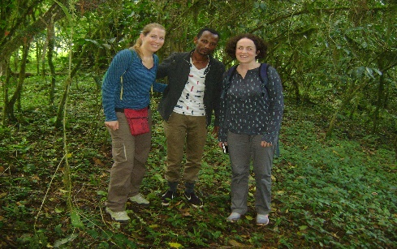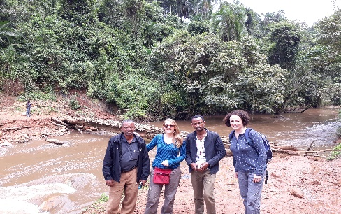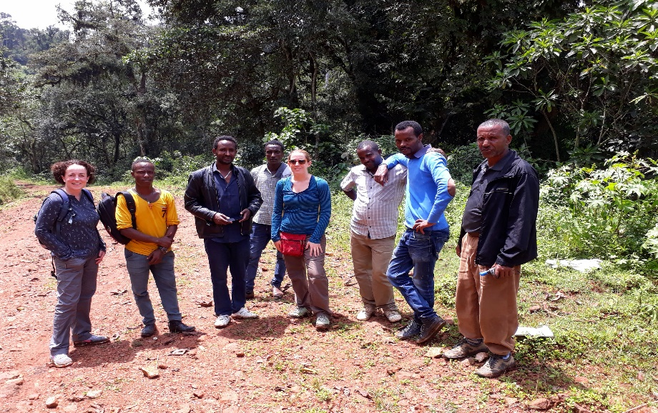

**Appendix A**

|  |  |  |
| --- | --- | --- |
| Topic | Notes/comments/questions | How could we (Laura and Louise) potentially support? |
| The **vision of EJHS**: *EJHS aspires to be the top preferred medical and health sciences journal in Africa by authors and practitioners.* | What does the vision translate to in real terms i.e. how do we know when EJHS is the preferred medical and health sciences journal in Africa, how do we monitor progress towards this vision and how do we get there? | 1. Analysis of the competitive situation (medical and health sciences journals in Africa), sharing and discussing the outcome with the EJHS team 2. On basis of above analysis discuss a journal development plan with the EJHS team including key metrics to help monitor progress.   The plans could include, for example,   * identifying key contributors in Africa (including Ethiopian/African diaspora?) to invite to submit. * identifying key topics to focus on * identify with the EJHS team potential candidates outside of Ethiopia to serve on the editorial/advisory board (to support the Africa-wide vision of the journal) * work with the EJHS team to develop a detailed understand of what attracts authors to EJHS via, for example, an online survey and/or local focus group * (online) promotion of the journal (see also next point) |
| Part of the **mission of EJHS** is *‘provide a forum for the presentation of research findings and scholarly exchange in the area of health and related fields’* | Related to the mission is there more that we could do in terms of journal-related activity to encourage scholarly exchange and in doing so promote the journal as a respected discussion forum? | * Explore with the EJHS team setting up an online discussion group using Mendeley to engage more authors (and prospective reviewers?) with the journal * Look at social network possibilities (twitter account @EthiopianJournal seems to be from EJHS but it has no information or posts), in EJHS there are YouTube, Facebook and Twitter signs which do not link to any account. |
| **Business plan** | We think qualifying/quantifying the vision/journal development plan as mentioned above is an important aspect of the business plan i.e. the more EJHS meets critical author needs the easier it will be to ensure sustainability by whatever means. However, some more detailed work on potential efficiencies/other sources of income could be beneficial. | Work with the EJHS team to expand on some aspects of the current business plan e.g.   * APC strategy (also in the context of the competitor journals analysis as mentioned above) and practicalities i.e. how to manage payments * Potential cost efficiencies * Research which means have been used in other AJPP journals to become financially sustainable |
| **Trainings/Seminars** | In order to prepare ahead, please select which trainings/seminars (if any) could be useful to give in Jimma University.  Any (anecdotal) information on which tools editors/authors use in a regular basis (and for what purpose) would be helpful e.g. (Scopus/ScienceDirect/Pubmed/Mendeley/ResearchGate /SciVal/Altmetrics/others) | * For authors: how can researchers use SD/Scopus/Mendeley; about literature reference management tools; how to showcase your research; … * For reviewers: what a good review should consist of? Ethics in publishing; … * For editors: how to look for potential authors/reviewers? Ethics in publishing; Metrics; … |

**Appendix B (key competitors highlighted in yellow)**



**Appendix C**

**Why Publish with Us (draft)**

Publishing with EJHS offers the following benefits

* Widespread visibility of their published work – EJHS is indexed in [MEDLINE](https://www.ncbi.nlm.nih.gov/labs/journals/ethiop-j-health-sci/), [PubMed Central](https://www.ncbi.nlm.nih.gov/pmc/journals/1611/), [AJOL](https://www.ajol.info/index.php/ejhs/about/submissions), [EBSCO *host*](http://web.b.ebscohost.com/ehost/command/detail?vid=0&sid=4e9f19a2-9b0a-4de2-aef5-af50992df23c%40sessionmgr103&bdata=JnNpdGU9ZWhvc3QtbGl2ZQ%3d%3d#jid=B8I2&db=aph), [DOAJ](https://doaj.org/toc/2413-7170?source=%7B%22query%22%3A%7B%22filtered%22%3A%7B%22filter%22%3A%7B%22bool%22%3A%7B%22must%22%3A%5B%7B%22term%22%3A%7B%22index.issn.exact%22%3A%222413-7170%22%7D%7D%2C%7B%22term%22%3A%7B%22_type%22%3A%22article%22%7D%7D%5D%7D%7D%2C%22query%22%3A%7B%22match_all%22%3A%7B%7D%7D%7D%7D%2C%22from%22%3A0%2C%22size%22%3A100%7D), [Africal Index Medicus](http://indexmedicus.afro.who.int/Journals/Journals%20datails/Ethiopian%20%20journal%20of%20Health%20sciences.html), [OVID](http://www.ovid.com/site/catalog/journals/13630.jsp), [HINARI](https://extranet.who.int/hinari/en/journalList_print.php), [Google Scholar](https://scholar.google.com/scholar?hl=en&q=Ethiopian+Journal+of+health+sciences&btnG=&as_sdt=1%2C5&as_sdtp=), [ROAD](http://road.issn.org/issn/2413-7170-ethiopian-journal-of-health-sciences-#.WKm1-VN961t)
* Open access publication ensuring immediate availability at no cost to the reader. EJHS also does not charge authors to publish Open Access
* A CC-BY end user license applies to each manuscript giving maximum flexibility for use of the content
* Authors can reuse their work published in the Journal
* In-depth and complimentary English language editing of accepted manuscripts prior to publication
* *Something about how the usage is increasing (if indeed this is what your google analytics reporting shows) and how the journal continues to increase in quality (you may want to quote a number of different quality metrics based on the table showing EJHS versus competitors)*
* Professional peer review process – we aim for a minimum of 2 reviews per manuscript
* No colour charges for print figures as required (we ask only that figures not requiring colour be published in black and white)
* Print copies of the journal are widely distributed within Ethiopia
* Complimentary copies of the print journal are available to authors upon request (we ask only that international authors cover shipping costs)
* User friendly submission process – EJHS utilises the ScholarOne online submission system to ensure an efficient process for authors and reviewers
* The EJHS editorial team aim to communicate a final decision to authors within x months (or weeks) – *related to this point we agreed we should not say anything about the total publication time because of the current accepted manuscript backlog*