**Research without borders**



***Malawi Medical Journal* – Blantyre, Malawi**

**jayne dawkins –September 15 – 30, 2017**

# **Overview**

The Malawi Medical Journal (MMJ) is a peer reviewed, open access, quarterly, general medical journal, published by the University of Malawi, College of Medicine and the Medical Association of Malawi. The MMJ serves as a forum for the dissemination of findings of health-related research undertaken in Malawi and beyond to health workers. It incorporates original research studies, policy analysis, case reports, literature reviews, and occasional special features.

The MMJ office is located on the campus of the University of Malawi, College of Medicine in Blantyre, Malawi. MMJ is the most advanced of the African journals in the AJPP program and is partnered with the *Journal of the American Medical Association* (JAMA).

* Publishing since 1979
* 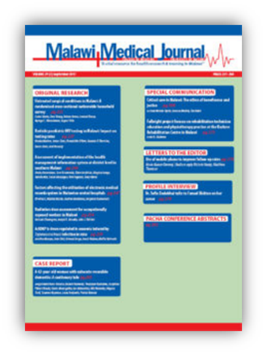Open Access
* Peer Reviewed
* Indexed in PubMed
* Indexed in Scopus
* Indexed in Bioline
* Published on African Journal Online
* Growing Impact Factor 0.837 (the highest ever)
* Active Website ([www.mmj.mw](http://www.mmj.mw))
* Active Twitter Page ([@MalawiMedJ](https://twitter.com/MalawiMedJ))

# **MMJ Editorial team**

The MMJ Editorial Team:

   

**Yohane Gadama**

**Intern**

**Fanuel Bickton**

**Intern**

**Thengo Kavinya**

**Managing Editor**

**Dr. Andrew A. Mataya**

**Deputy Editor**

**Dr. Lucinda Manda-Taylor**

**Editor in Chief**

I found the MMJ’s editorial team to be smart, dedicated and passionate about the growth of the journal. They were welcoming and open in communicating with me and receptive to all of my instruction, suggestions and advice.

They were all very busy as all but one of members have full time jobs a part from their MMJ editorial duties. Along with being Editor-in-Chief of MMJ Dr. Lucinda Taylor, a bio-ethicist and social scientist, is a Senior Lecturer at the University of Malawi, College of Medicine. Dr. Taylor made time for our meetings between teaching and her other responsibilities allowing for numerous meetings throughout the 2 weeks I was there.

Prior to travelling to Malawi, Dr. Taylor provided the email address of her team members so that I could schedule meetings beforehand. That was very useful. I was fortunate to meet a number of the MMJ board members and to present at their board meeting that just happened to have been scheduled on my last day there. The board members were very engaged, interested in and impressed with all that we had accomplished in only 2 weeks.

All of my meetings were held on the campus, either in Dr. Taylor’s office or in the MMJ’s office. As well, the MMJ Board Meeting was held in the main conference room located in the newest building on campus, the Library. I worked in the library when not in meetings.

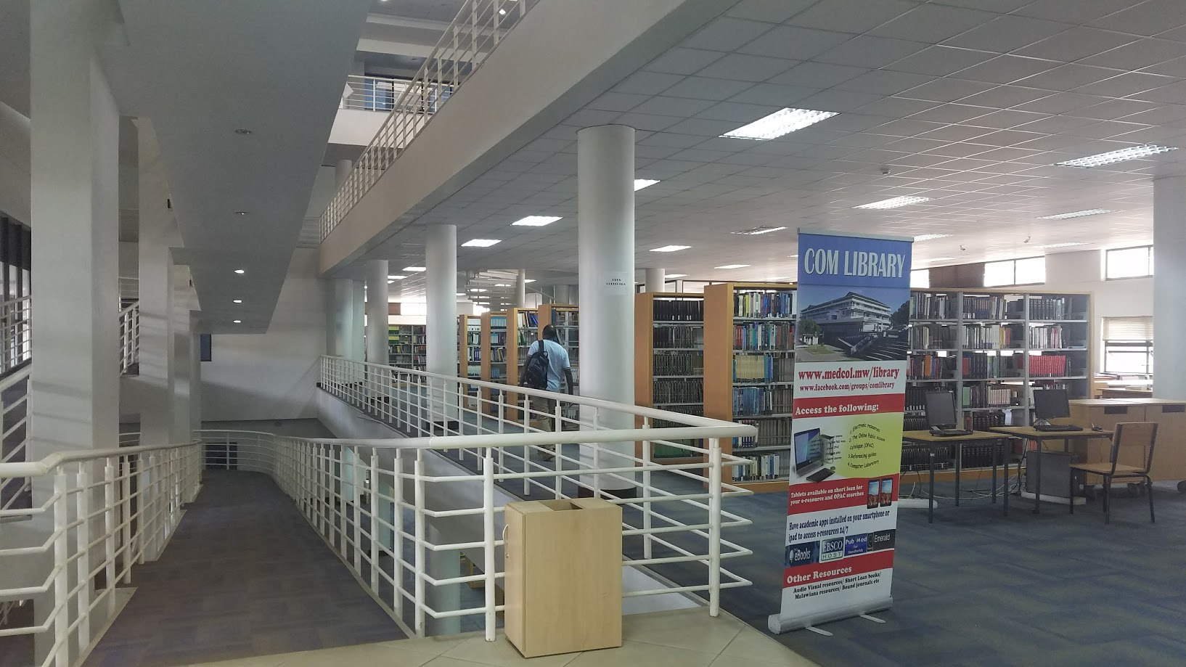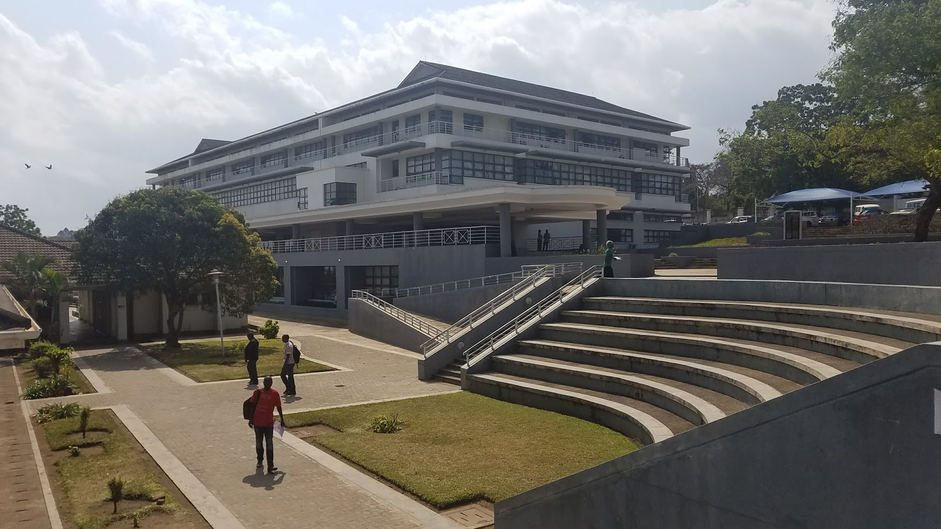

# **objective**

The purpose of my visit was to work closely with Dr. Lucinda Taylor and her editorial team and set in place a plan to achieve the following objective. Upon learning about the journal from members of the team, we determined our areas of focus. I then set forth creating and giving presentations specifically tailored to MMJ. I also set forth gathering information that was included in the planning documents that I wrote for the team to use for marketing and promotion of MMJ throughout 2018, and to use as guides going forward.

**Objective:**

Increase promotion and dissemination of the research published in the *Malawi Medical Journal* throughout Malawi and Africa, and deepening the journal’s presence in the digital world.

**Areas of Focus:**

* Campaign development
* Article collections and special issues
* Author services
* Social media
* Branding

**Planning for 2018:**

* Market overview
* SWOT/TOWS analysis
* Submissions analysis
* Citation analysis
* Competitive analysis

# **accomplishments**

The research that I had done prior to the trip, in an effort to learn as much as possible about the journal, along with reaching out to the editorial team members to preschedule meetings allowed me to hit the ground running. That, coupled with the contributions from the editorial team, allowed us to accomplish a great deal in 2 short weeks. All presentations and documents are located in the MMJ dropbox that is accessible by all editorial team members.

In addition to teaching about various promotions and how to maximize MMJ content by creating article collections, using regional and world health days and holidays, how to promote the editor with editor’s choice campaigns, the importance and impact of integration, etc.; I’m truly pleased that we were able to actually produce a few of these campaigns from start to finish while I was there, as well as lay the framework for campaigns to deploy in October and December.

I remain in contact with Dr. Lucinda Taylor and am I’m happy to report that both the October and December campaigns were completed and deployed as planned.

**Outcomes**

**15 - 30 September 2017:** Numerous meetings, presentations, campaigns and documents developed

* **Presentations Given**
  + Campaign Strategy tied to Objectives
  + Social Media for Medical Journals
  + Author Benefits/Services Campaigns
  + Author Workshops
  + Getting Your Paper Noticed
* **Documents Provided**
  + 2017 Action Plan (October – December)
  + 2018 Comprehensive Marketing Plan
  + Social Media Plan
  + Twenty-five Examples of Various Types of Email Campaigns
* **Campaigns Created**
  + Spotlight on Maternal Health in Malawi Virtual Special Issue
  + World AIDS: Achieving the 90-90-90 Target
  + Editor’s choice article collection email
  + Social media promotions tied to regional holiday and world health day
* **Ongoing Communication**
  + Remain in touch with Dr. Lucinda Taylor and her team
  + Available for questions that arise and provide guidance on campaigns
  + Check-in from time to time to see how the campaigns are going
  + Forward information that I come across that may be useful

**28 September 2017:** Deployed an Integrated Virtual Special Issue (VSI) Campaign

* Article selection and VSI written introduction by Dr. Lucinda Taylor
* Virtual Special Issue: Spotlight on Maternal Health in Malawi
* Campaign Integration: MMJ website, email, social media
* Campaign Deployed : 28 September 2017

**30 September 2017 :** Presented before the MMJ Board of Directors at their summer meeting

**16 October 2017**: Social Media Campaign

* A series of promotional tweets posted throughout that week tying the September VSI to the Malawian holiday, Women’s Awareness Day / Mother’s Day

**1 December 2017:** Deployed an Integrated VSI Campaign

* Article selection and VSI written introduction by Dr. Lucinda Taylor
* Virtual Special Issue: World AIDS: Achieving the 90-90-90 Target
* Campaign Integration: MMJ website, email, social media
* Campaign Deployed : 1 December 2017

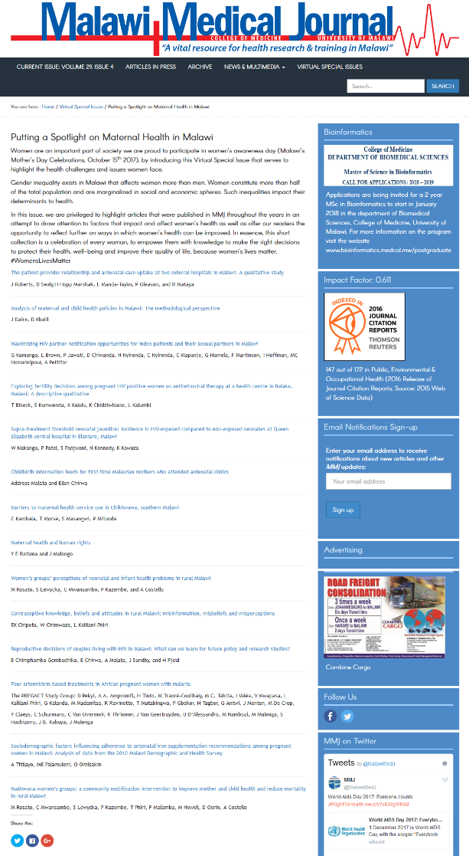 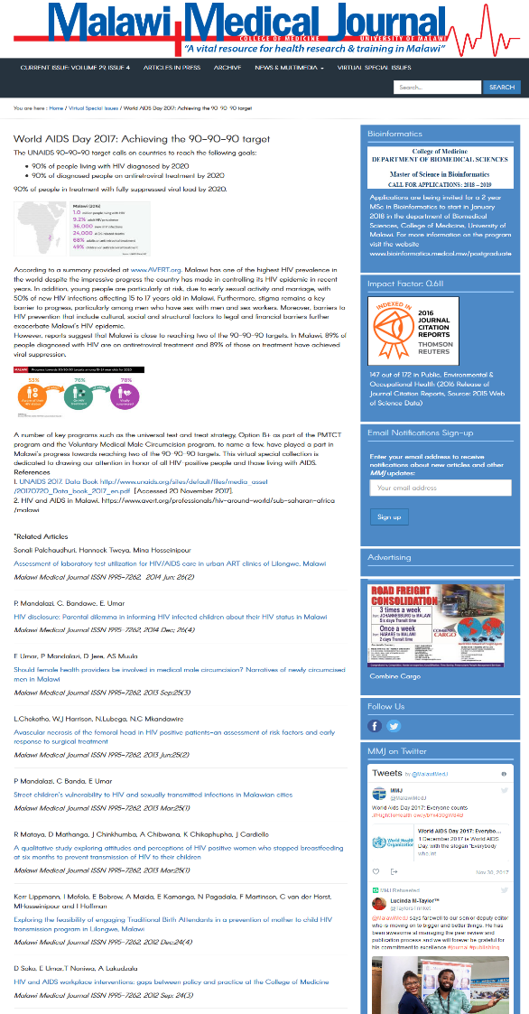

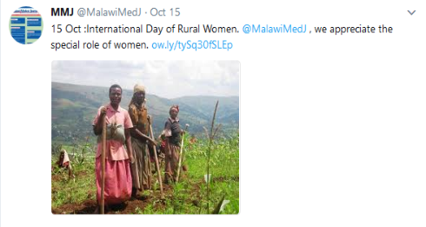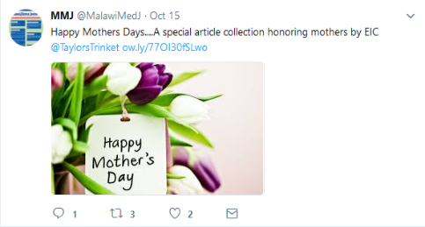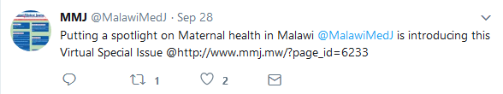

# **Final Considerations**

MMJ’s greatest asset is its dedicated and passionate Editor-in-Chief, Dr. Lucinda Taylor, and team.

The MMJ has great potential to increase the visibility of its content in Malawi, sub-Saharan Africa regions and beyond, through focused, targeted, integrated and frequent email, social media and pay-per-click campaigns. There is a volume of published content from which article collections can be created and promoted to specific audiences. Call for papers campaigns can be created to solicit papers on specific topics, etc. Additionally, promoting content related to world and regional health days, hot topics and using proper hashtags can lead to greater readership and usage of MMJ content.

These types of campaigns and more are included in the 2018 Marketing Plan that the editorial team will hopefully strive to follow. I have made myself available to support these efforts however possible. However, MMJ faces challenges with accurately and effectively marketing its content. The availability of funds are needed to obtain and support tools/services to efficiently promote MMJ (content, activities and information) on social media, to efficiently deploy email campaigns, to provide metrics and accurately analyze campaign results, and to enhance the functionality of the website.

Annual subscriptions to services like Hootsuite or Spredfast, Adobe, Google Tags, Scopus, Altmetrics, Pay-Per-Click campaigns, etc. would allow necessary knowledge to track the success of all digital campaigns.

# **lodging**

The Leslie Lodge was very comfortable and the people who worked there were extremely friendly and accommodating. Each room had a kitchen area and patio. The location was great, across the street from the College of Medicine campus and about a 10 minute walk from the MMJ office and library. The food was fine. Breakfast was included in the room cost and dinner was a modest charge per night that was paid for at checkout. Bottled water was sold there. Cooking in your room was an option too. Internet cards were sold at the lodge and was reliable. The generator would kick in when the electricity went out. There were 5 television stations: 2 were movie stations, 1 was a world news station and the other 3 were sports stations. All were in English. The Lodge also exchanged American dollars for Malawian Kwacha which was very convenient.

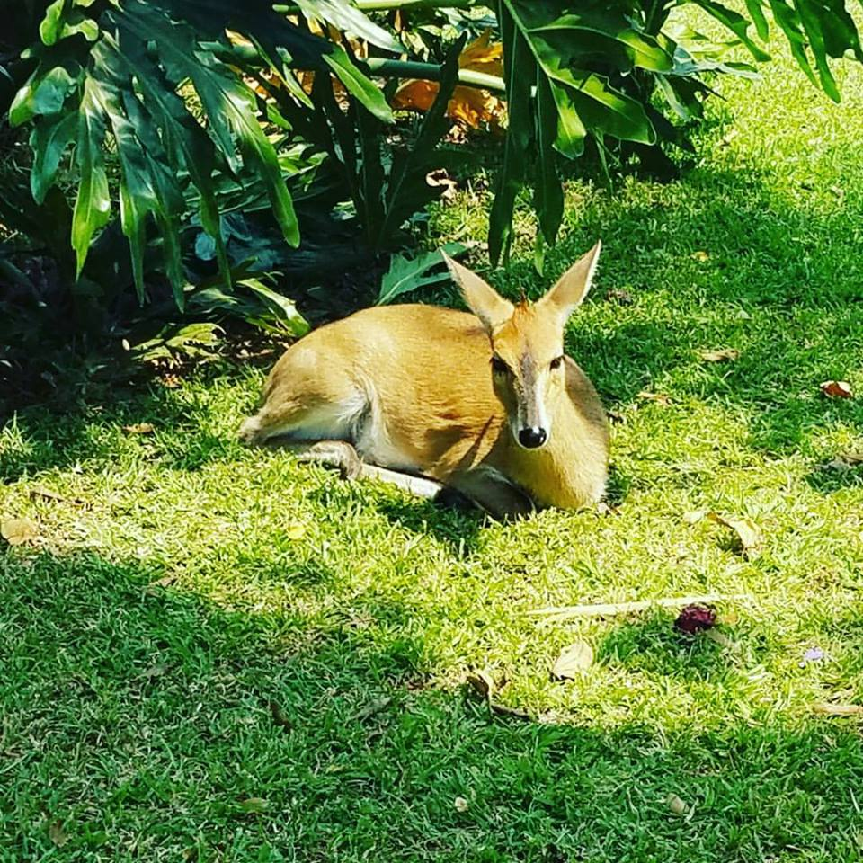

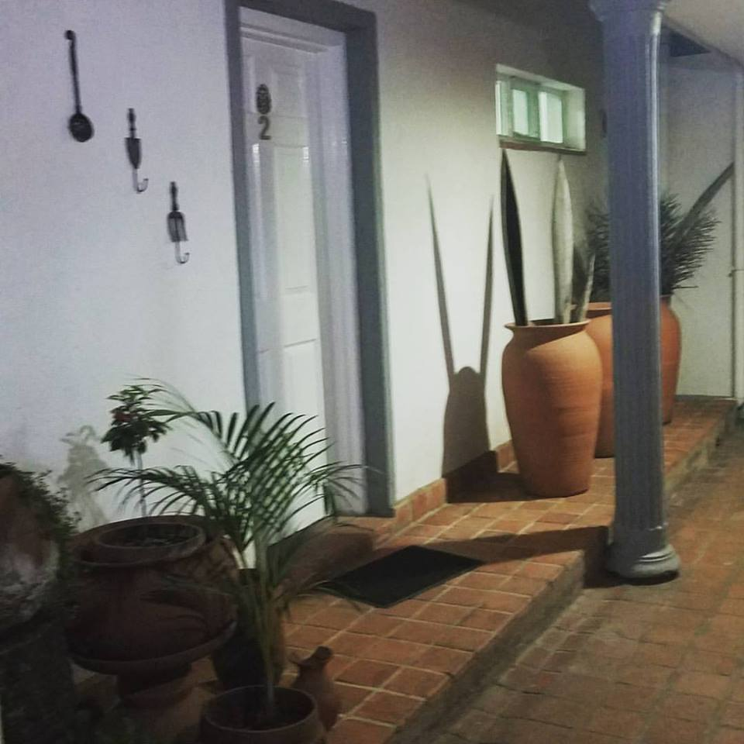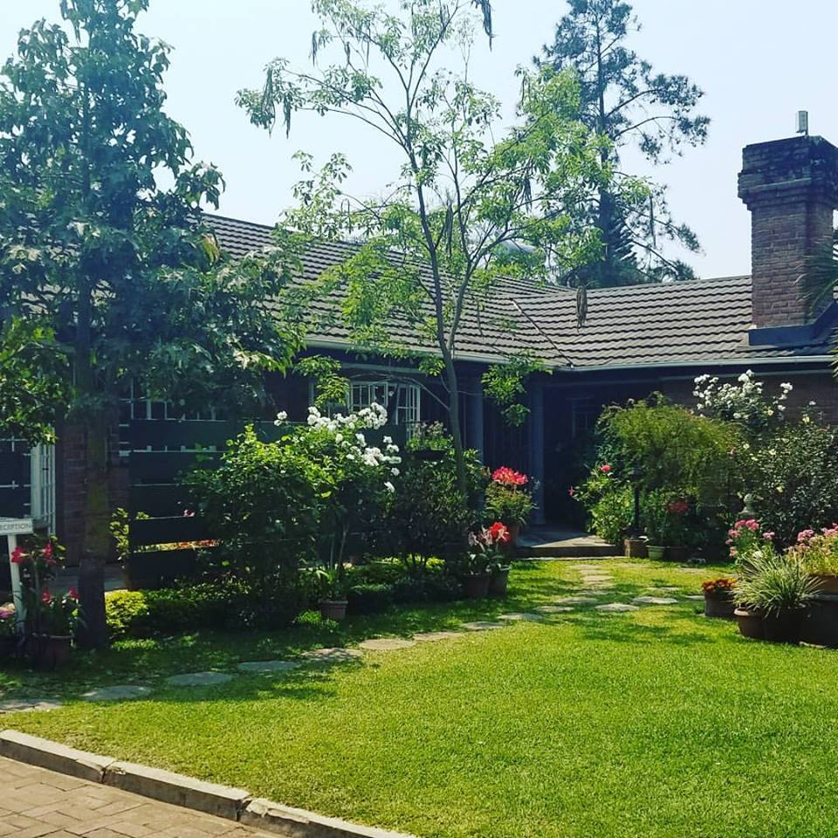

**The Leslie Lodge’s resident Dika, Rosie.**

# **personal Reflections**

**Life Changing Experience –** I am truly grateful to the Elsevier Foundation and the AJPP for the unique and wonderful opportunity to serve as a Research Without Borders marketing volunteer.

It was professionally rewarding to share my marketing knowledge and skills with the MMJ editorial team. To see how this knowledge is valued by those who received it was gratifying.

I met some really awesome people starting with the MMJ Editor-in-Chief, Dr. Lucinda Manda-Taylor. She was smart, warm and friendly, honest and easy to work with. She’s a true leader and I enjoyed working with her and her team.

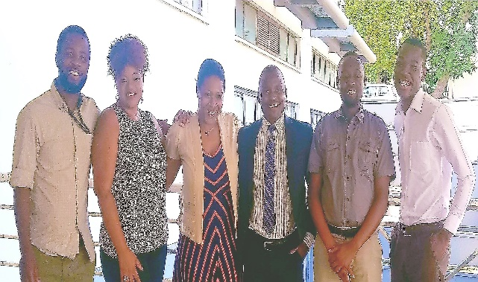

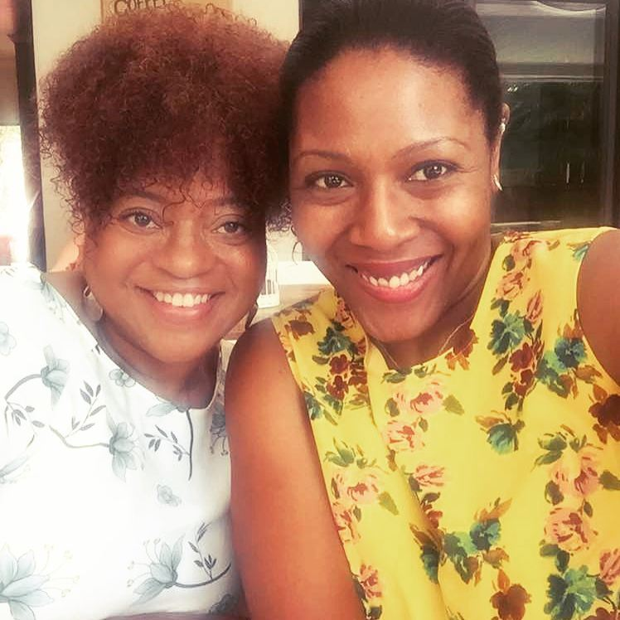

Dr. Lucinda Manda-Taylor, MMJ Editor in Chief

Jayne Dawkins, Elsevier Marketing Communications Manager

The MMJ Editorial Team with Jayne Dawkins,

RWB marketing volunteer

This was my first time visiting Africa and I enjoyed taking-in the people, culture and the land. I saw a lot of beauty in Malawi. I also saw a lot that made me value and appreciate life, first world amenities, Elsevier, and opportunity – all the more.